Grainger Salesforce / Website Integration
A new website is being built that will contain all properties and a subset of available units / units that will be available soon.

Connect to their API & send payload to their API
They will build API to send new leads and connect to existing SF lead
- Assume don’t need to pass any picklists etc to website
- Assume don’t need to enhance lead with new attributes

- #1: Unit Details API - Push available / live unit information from SF to website
  - Published - Use existing flag on the unit that determines whether unit details are sent to RightMove (ILS). Checking the box will now send to RightMove and the website.
  - Current analysis of fields required and whether they are already in SF: https://docs.google.com/spreadsheets/d/1GelVoarLBPpkYizANiWmIQSj4RuPBAFFW8bXgAxEebY/edit?pli=1#gid=0
    - Probably not complete
    - Need to have more nuanced information than sent to rightmove. E.g. if available date is in the past it should say “Available Now” rather than “Available in March”.
  - Will include adding new fields to SF where required.
    - Assume any data clean-up is not in our scope.
  - Will send images and documents (floor plans, EPC, EPC graph, 360 tours, virtual tour[future] ) to website.
  - Unit description to remain in SF. Building and feature level info will be in CMS.
  - Unit features will be a combination of unit, building (aka development), block = estate object data.
    - Ideally have a standard set of features for RM & website.
    - Currently a key features section in SF = a string field.
    - Need to augment/update existing feature list.
    - Should be able to have a code short description, long description, etc for each feature. Ideally want to send a code through in API.
      - Details about that feature code will be managed in the website CMS per property.
      - Can’t break RM tho.
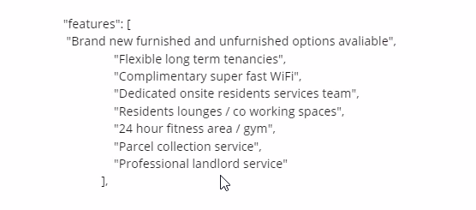
- TBD if we need a separate API to push property-level information to a property information page. I don’t think so.
- #2: create leads in SF
  - user will fill in a form on the website that will create a new lead in SF. Want to be able to capture more lead info upfront than currently receive.
  - The prepopulated lead fields will be locked down in SF.
  - Assumed all existing fields in SF.
  - Will need to source dropdown values from SF to display on the form.
  - Out of scope = G have a separate project looking at customer lifetime value which will include prioritizing leads.
    - Need to push back attributes that will feed into the prioritization. E.g. if a building is not yet open so that these leads will be prioritized lower.
- Other general website content will be managed thru another CMS.
- Go live May/June.
  - March for #1
- Assume we don’t need to merge leads e.g. where there is
- Stakeholders
  - Jon, Kurt Mueller (marketing), Elisa Pattison (COO)
- API integration security - TBD
  - GREP integration not required
  - Security: Network restrictions (?)
    - Not using API keys.
    - Authentication layer required.
    - Assume REST API with OAuth.
- Will deliver updated estimates after analysis.

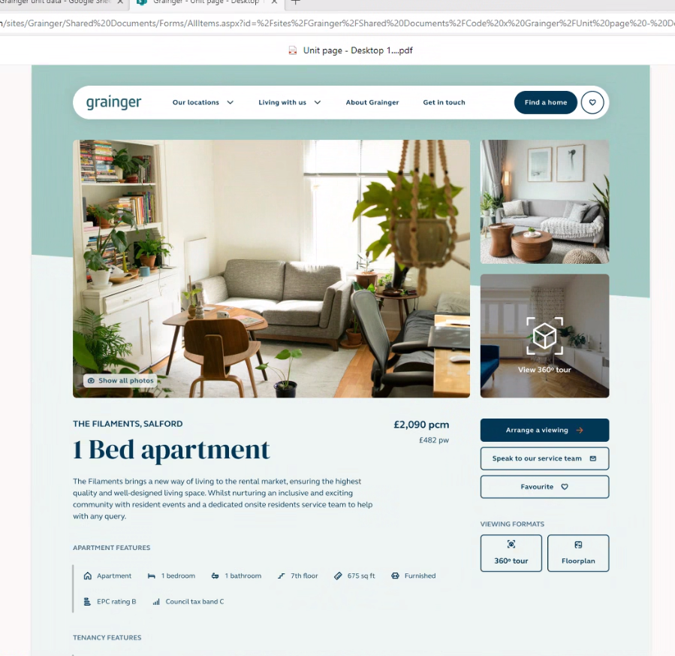
- Probably won’t have actual EPC rating and council tax band displayed. Don’t have this info. Or if not known – don’t display.
  - Might just add a flag to display ‘best EPC rating’ to buildings.

